307687749 Vandna

**General Scope:**

**Customer module**

Customer Registration, Login, forgot / reset password, profile view / edit

Customer Feedback CRUD

Customer query CRUD

Project list, view status, estimation and insert review

**BDE module**

BDE Registration, Login, forgot / reset password, profile view / edit

Send customer an invite for registration

Project detail CRUD, estimation CRUD for each project

List projects all, for specific customer

Customer Feedback view

Customer query view / update with response

**Admin module**

All user view, activate / deactivate

Customer Feedback view

Customer wise project list with full details view

Login -> Email ID, Password

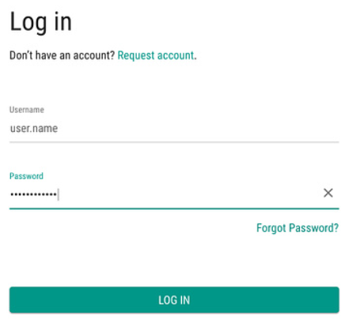

Registration -> (User name, email ID, Password, Type (Customer, **B**DE), Status [**A**ctive, **I**nactive])

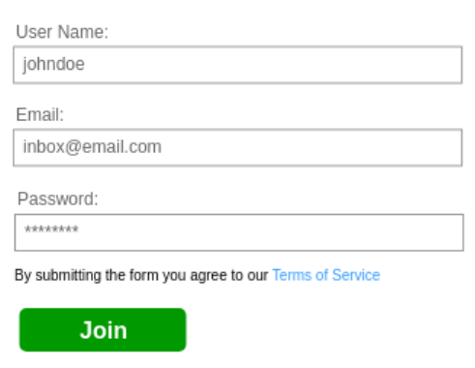

Forgot password ->

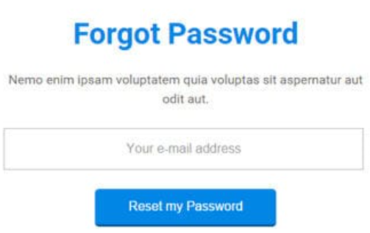

Reset Password ->

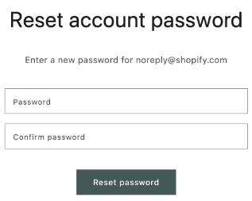

Project Detail -> (Project code, name, description, customer name, customer contact number, customer email, customer address [address line, city, state, country], duration (man days), cost (amount USD), remarks, status)

Customer Feedback -> (Email, Description, Suggestion)

Customer Query -> (Description, Suggestion, Response)

Portfolio will be good.